Name_________________________
Date________________Bell_______

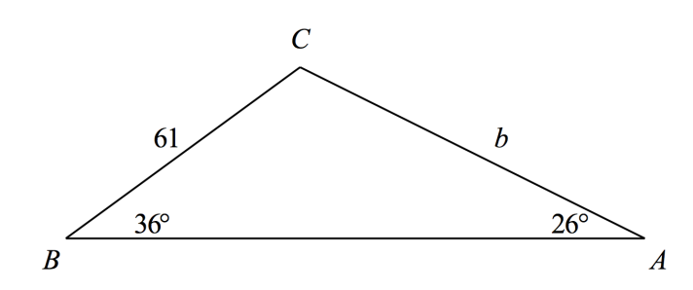
Find the indicated measure. Round to the nearest tenth. Show all work.
1) Find side b.

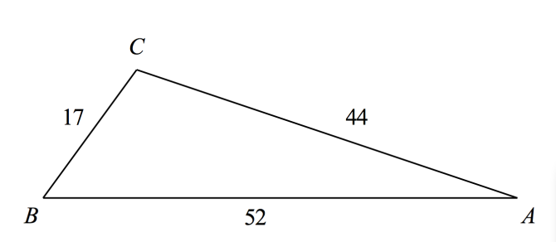
2) Find angle A.

Use the given information to solve the entire triangle, if possible. If two solutions exist, list both. Include a labeled drawing. Round to the nearest tenth. Show all work.
3) a = 4, c = 7, B = 110º

4) A = 50º, a = 22, b = 25

5) A small fire is sighted from ranger stations A and B. Station B is 1.6 miles due east of station A. The bearing of the fire from station A is N40ºE and the bearing from station B is N50ºW. How far, to the nearest tenth of a mile, is the fire from station A? Draw a picture and show all work.

6) An oil tanker and a cruise ship leave port at the same time and travel straight-line courses at at different directions. They travel 10 mph and 25 mph, respectively. Two hours later they are 40 miles apart. What is the angle between their courses? Draw a picture and show all work.

7) Two ships leave from port, one traveling 15 nautical miles per hour and the other traveling 17 nautical miles per hour. After 3 hours, the angle between the ships is 72º. How far apart are the ships after 3 hours? Round to the nearest tenth. Draw a picture and show all work.

8) On the edge of the sea, two Lighthouse Stations are 20 miles apart, with Station 1 directly south of Station 2. Both stations spot a ship in distress. The bearing of the ship from Station 2 is N78ºE, and the bearing of Station 1 is N31ºE. How far to the nearest tenth of a mile is the ship from Station 2? Draw a picture and show all work.

9) The angles of elevation to an airplane from two points A and B on level ground are 51º and 68º respectively. The points A and B are 2.5 miles apart, and the airplane is east of both points in the same vertical plane. Find the altitude of the plane. Draw a picture and show all work.

